
AMHERST - HIRED METAL DETECTOR WANDS

UNPACKING & SETTING UP THE SECURITY WANDS

Open the box(es) supplied carefully, so you can re-use them to return the equipment later. Tell us if anything is missing or damaged straight away. Please keep all the packaging for returning the equipment.

The security wands are supplied completely “ready to go” with a rechargeable battery already fitted in the end of the handle.

GETTING READY TO USE THE SECURITY WANDS

Switch the wand on using the on/off switch – press it to “ON” or “1”. The wand should “beep” once and the power LED will come on. The security wand is now ready to use.

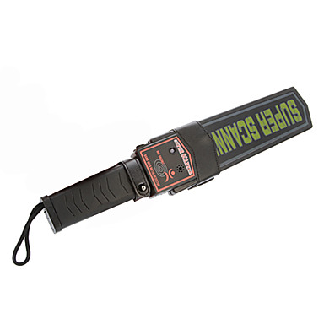
The wand will respond when it detects metal close to its detector head. It can respond in two ways, depending on the “selector” push button on the side of the wand:

“NORMAL” (BEEP) MODE – with the push-button “out”, the wand will BEEP loudly and the LED show red when metal is detected.

“SILENT” (VIBRATE) MODE – with the push-button “in”, the wand handle will vibrate and the LED show red when metal is detected.

The “silent” mode is useful if the wand is used in a noisy place where the “beep” may not be heard, or also in a situation where the user does not want the “beep” to be heard by people around them.

HOW TO SEARCH SUBJECTS USING THE SECURITY WAND

The user should pass the wand slowly over the subject’s clothing, especially over all their pockets and any other areas where a metal object (for example, a weapon) might be concealed.

The wand should only be a few centimetres (no more than 10cms) away from the subject’s clothing, to ensure that even small metal objects are detected.

When the wand beeps or vibrates, the user should ask the subject to take out whatever objects are in their pockets etc for the wand user to inspect.

The advantage of searching people using these wands compared with “frisking” them, is that it is less “intrusive” and avoids embarrassment.

It also largely avoids the issue of having to have female security staff to “frisk” female subjects etc.

CHANGING THE SECURITY WAND BATTERY

The wand’s battery is located in the end of the handle of the wand.

Slide the battery door off to reveal the bottom end of the battery.

Be careful not to lose the battery door – the wand cannot be used without it.


The small 9 volt “PP3” battery should drop out if the wand is held vertically.

Sometimes it needs to be pried out with the end of a screwdriver etc.

Any type of battery can be used, both “throwaway” and rechargeable.

Insert the new battery, and slide the battery door back into place.

If the wand does not come on, try inserting the battery the other way round. You will not damage the wand if you insert the battery the wrong way round.

PLEASE NOTE THAT THE BATTERIES THAT WE SUPPLY ARE RECHARGEABLE, SO IF YOU TAKE THEM OUT, PLEASE DO NOT THROW THEM AWAY!

THEY COST AROUND £5 EACH TO REPLACE.

RETURNING THE SECURITY WANDS

Switch each wand “off” so that they will not “beep” while in transit.

Pack the security wands away in the box(es), including any rechargeable batteries that you may have removed, any battery chargers that we may have supplied, and this instruction sheet, and send it all back to us at:

Amherst Enterprises Limited
70 Kingsgate Road
LONDON NW6 4TE Tel: 020 7328 9792

Make sure that you include some paperwork to tell us who the package has come back from!

Please use a “trackable” or “signed-for” delivery service with appropriate insurance, our equipment is your responsibility until we get it back here.

The security wands are your responsibility until we get them back to our office. If you accidentally dropped or damaged anything, or had other problems with it, please let us know what has happened.

